

**TRIBHUVAN UNIVERSITY**

INSTITUTE OF SCIENCE AND TECHNOLOGY

**AMRIT SCIENCE CAMPUS**

LAINCHAUR, KATHMANDU



**Word Processor**

**SUBMITTED BY**

Name: Tarun Regmi

Roll No: 2012/078

BIT 1st Sem

**SUBMITTED TO**

Gyani Ray

Lecturer

Amrit Science Campus

# What is word processor (MS Word)? Briefly describe its features and application.

A word processor is an application software used for input, editing, formatting and output of text. Word processors facilitate writing and editing, especially with their ability to copy and move text, their built-in dictionaries to check spelling, and their grammar checkers. Other common features include a wide choice of typographic fonts and sizes, various paragraph and page layouts, tools for finding and replacing strings of characters, and word counts. Modern word processors also have many features once reserved for desktop publishing systems, such as table creation and importation of graphic images. They typically provide templates for common document types, such as letters, memos, and resumes, and can generate multiple copies of a document. Microsoft Word, Google Docs, WordPerfect, etc are popular example of word processor.

## Microsoft Word (MS Word)

Microsoft Word is a word processing software developed by Microsoft Company. Microsoft Word was initially launched in 1983. Nowadays MS Word is the most popular and widely used commercial word processor. Microsoft Word is a component of the Microsoft Office suite of productivity software, but can also be purchased as a stand-alone product.

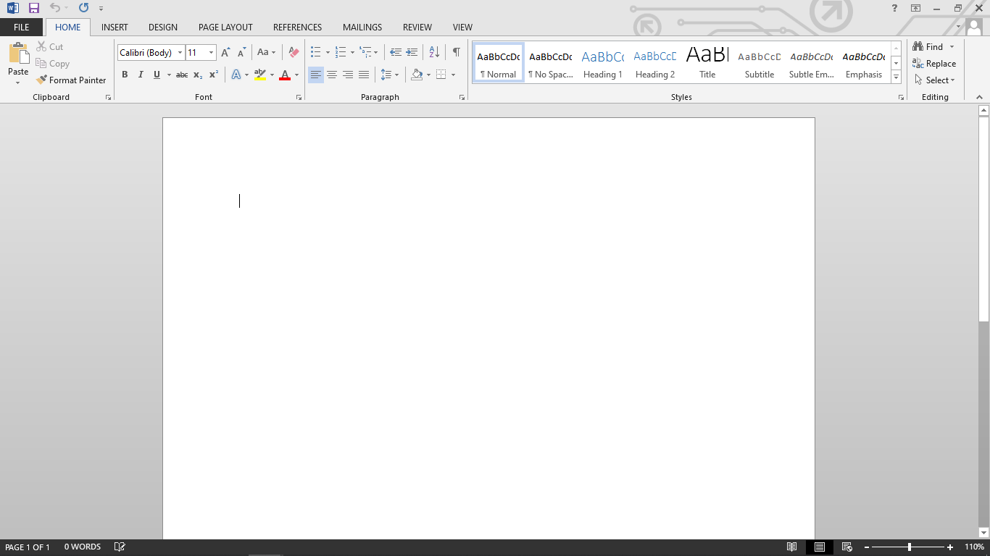**Fig: MS Word Interface.**

### How to open MS Word in In Compute?

Follow following steps to open MS Word in computer.

1. Click on **START**
2. Search **MS Word**
3. Click on **MS Word Icon**

### How to create file in MS Word?

Follow following steps to create file in MS Word.

1. Open **MS Word**
2. Click on **Blank document**
3. 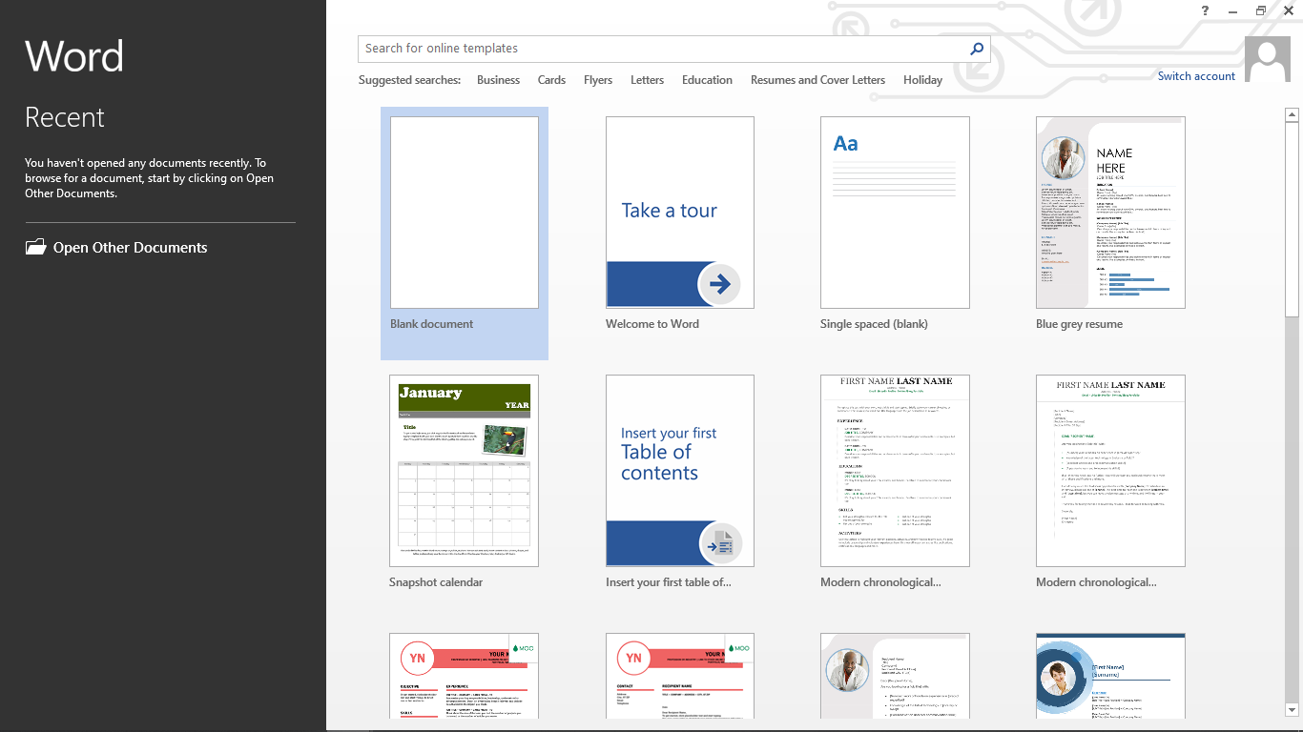Or click on other available template

**Fig: Creating word file**

After creating the file if you want to save the created file then follow the below steps to save that file.

1. Click on **FILE BUTTON**
2. Click on **Save**

### Features of MS Word

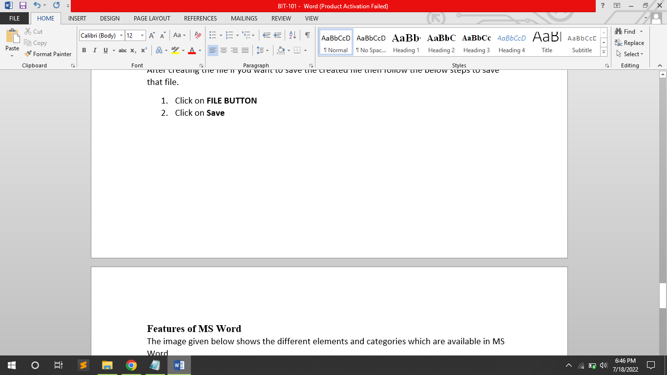The image given below shows the different elements and categories which are available in MS Word.

#### HOME

This has options like font color, font size, font style, alignment, bullets, line spacing, etc. All the basic elements which one may need to edit their document is available under the Home option.

#### INSERT

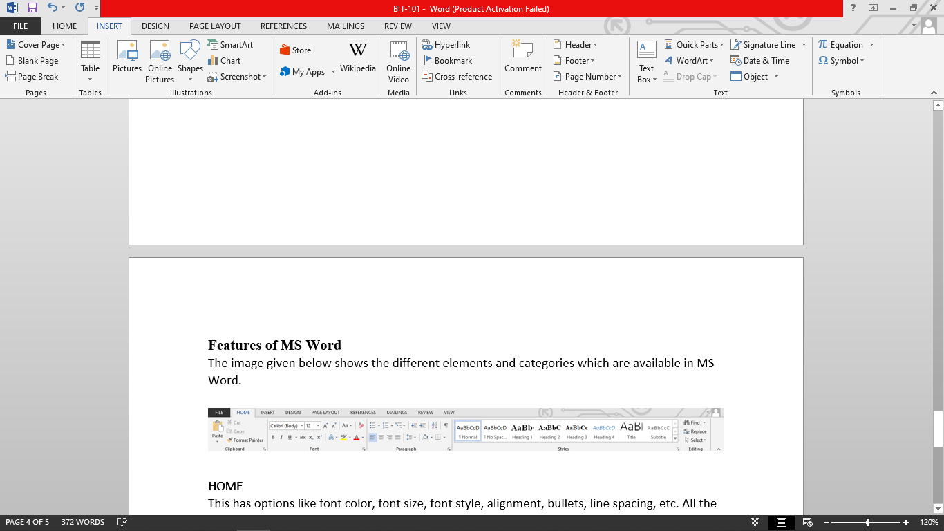Tables, shapes, images, charts, graphs, header, footer, page number, etc. can all be entered in the document. They are included in the “Insert” category.

#### DESIGN

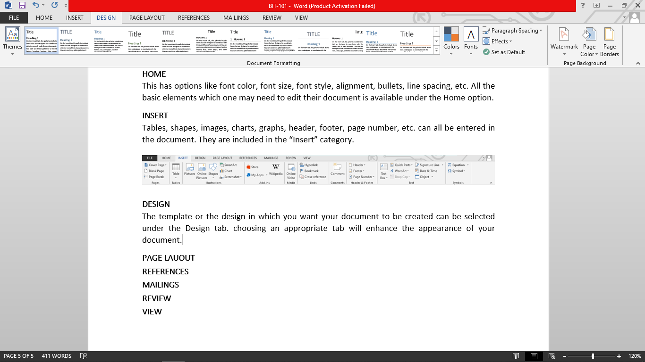The template or the design in which you want your document to be created can be selected under the Design tab. choosing an appropriate tab will enhance the appearance of your document.

#### PAGE LAUOUT

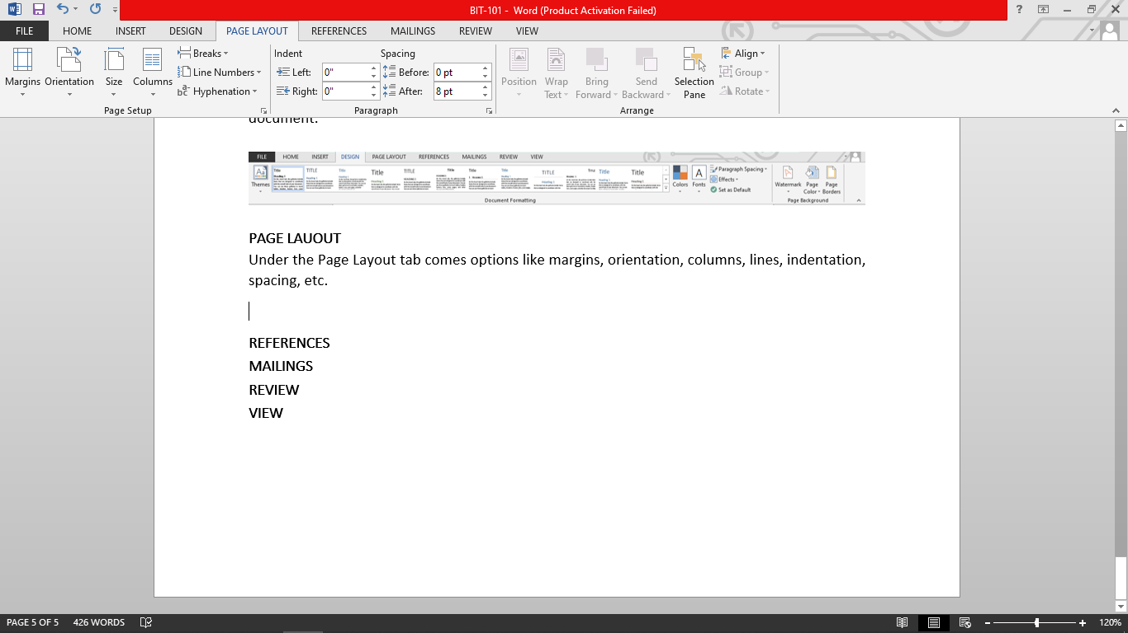Under the Page Layout tab comes options like margins, orientation, columns, lines, indentation, spacing, etc.

#### REFERENCES

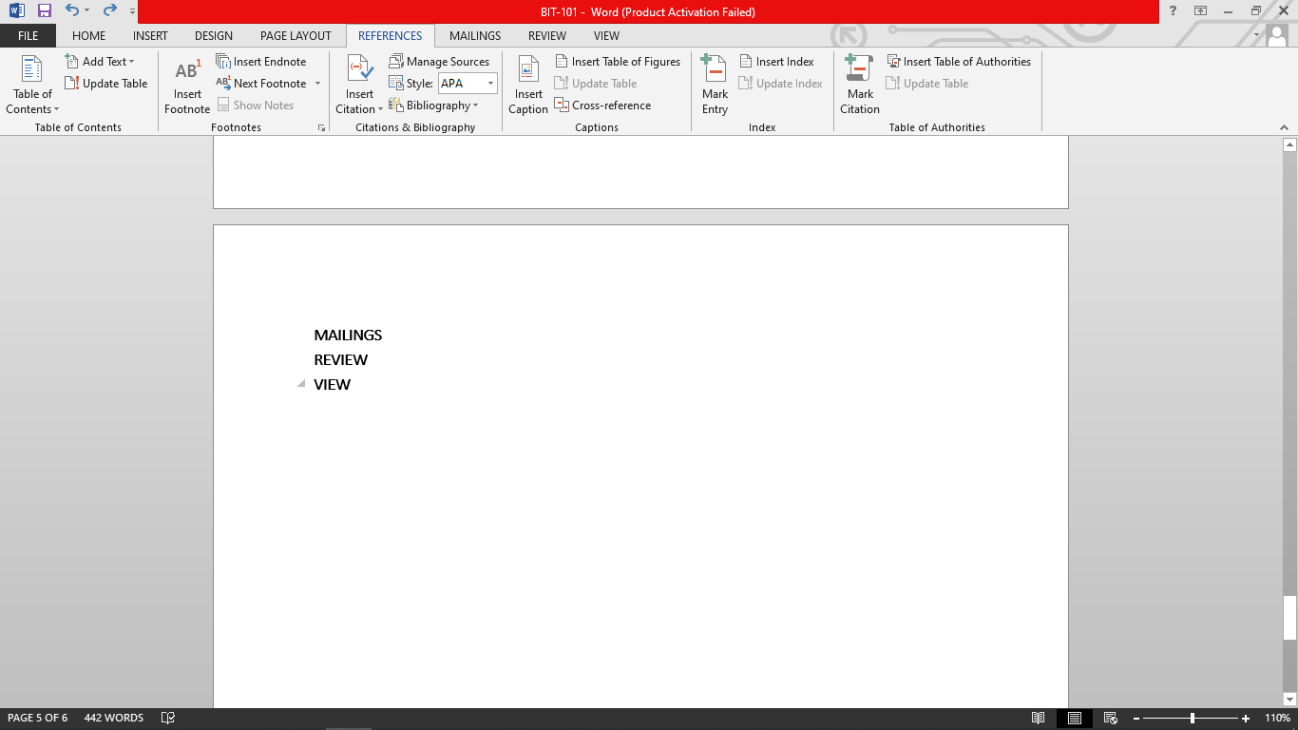Options like citation, footnote, table of contents, caption, bibliography, etc. can be found under this tab.

#### REVIEW

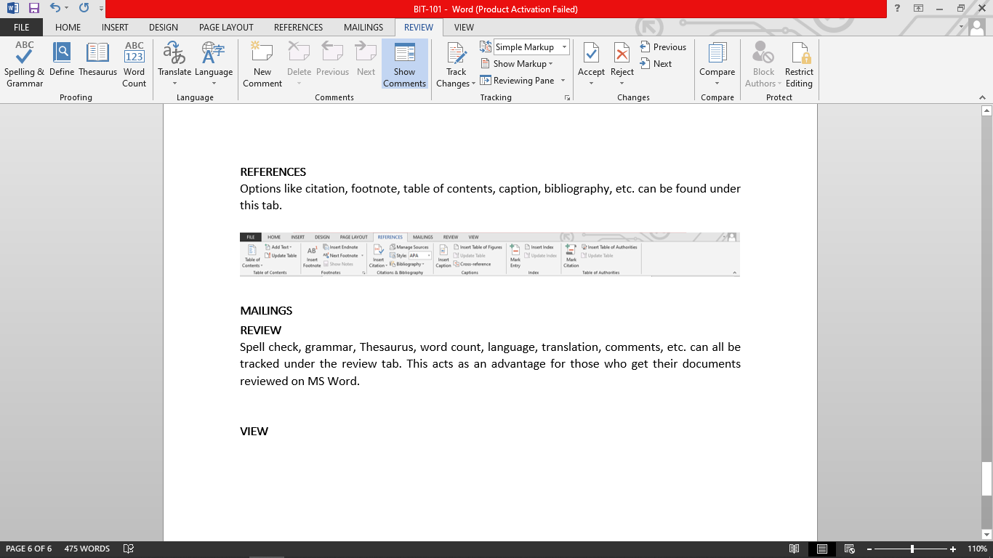Spell check, grammar, Thesaurus, word count, language, translation, comments, etc. can all be tracked under the review tab. This acts as an advantage for those who get their documents reviewed on MS Word.

### Shortcuts for Microsoft Word

|  |  |
| --- | --- |
| Shortcut | Meaning |
| Ctrl + A | Select all contents of the page |
| Ctrl + B | Bold highlighted selection |
| Ctrl + C | Copy selected text |
| Ctrl + I | Italicize highlighted section |
| Ctrl + J | Justify paragraph |
| Ctrl + N | New document |
| Ctrl + M | Indent the paragraph |
| Ctrl + O | Open document |
| Ctrl + U | Underline highlighted section |
| Ctrl + V | Paste selected text. |
| Ctrl + X | Cut selected text |
| Ctrl + Z | Undo last action |
| Ctrl + Shift + A | Format letters as all capitals |
| Ctrl + Shift + F | Change the font |
| Ctrl + Shift + W | Underline words but not spaces |
| Ctrl + left arrow | Moves one word to the left |
| Ctrl + right arrow | Moves one word to the right |
| Ctrl + up arrow | Moves to the beginning of the line or paragraph |
| Ctrl + down arrow | Moves to the end of the paragraph |
| Ctrl + Del | Deletes word to the right of cursor |
| Ctrl + Backspace | Deletes word to the left of cursor |

## Creating CV using MS Word

**EDUCATION**

|  |  |  |  |
| --- | --- | --- | --- |
|  | SCHOOL | GPA | Year |
| SEE | JANA PRAKASH MA VI | 3.25 | 2076 |
| +2 | LABORATORY BOARDING SECONDARY SCHOOL | 2.75 | 2078 |
| Bachelor | Amrit Science Campus | Running | 2078 |

**SKILLS**

|  |
| --- |
| C |
| HTML |
| CSS |
| JavaScript |

Address: Lokantahali – 01, Bhaktapur

**Curriculum Vitae**

Name: Tarun Regmi

Nationality: Nepali

Phone: 9868632910

E-Mail: tarun.regmi.sch@gmail.com

GitHub: [https://github.com/tarunregmi](https://github.com/tarunregmi%20)